IV International Niš Games
“In This Sign You Will Conquer”
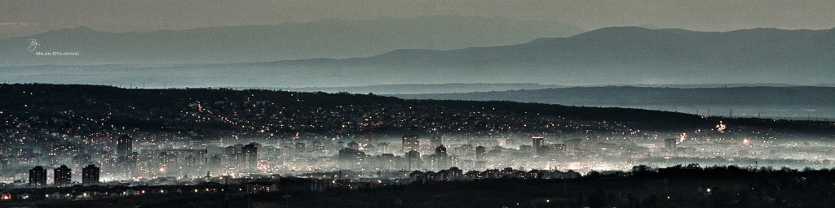
International Police Association, Section Serbia, Region Niš,
for members of IPA, employees in Ministry of Interior, friends,...
on 05/06/07.10.2018. organize IV NIŠ GAMES, called
“In This Sign You Will Conquer”
Welcome friends, colleagues, members of IPA, to the city of Constantine the Great!!!
Schedule for the competition of IV Niš Games 2018
1. Day: Friday 5th of Oktober 2018 from 16:00h
Reception of competitors and foreign delegation, who arrive a day early, accommodation in Zeleni vir
19:00h – dinner with music (restaurant Zeleni Vir), overnight stay.
2. Day: Saturday, 6th of Oktober 2018
08:00 – 09:00h – Breakfast (restaurant Zeleni Vir)
09:15h – Official opening of the competition (Sports hall Čair)
09:30 – 13:00h – Competition
13:00 - 14:00h – lunch (restaurant Dušanov konak)
14:00 - 17:00h – Returning to the accommodation units, rest.
19:00 - 02:00h – Gala dinner at the restaurant Zeleni Vir; Awards program (sport cups and certificate of appreciation); Gala dinner for all participants and friends with rich cultural and artistic program
3. Day: Sunday, 7th of Oktober 2018
08:00 – 10:00h – Breakfast (in accommodation units)
10:00h – city tour, guest send off

COMPETITION DISCIPLINES:

1. 3-point shooting contest
2. Shooting the cones
3. Shooting with an air gun
4. Shooting with bow and arrow

Registration fee per participant:
-Participants who arrive on 05.10.2018. (Includes dinner on 5th of September, two nights with buffet breakfast, lunch on 6th of Oktober, and gala dinner on 6th of Oktober) - 6.500 RSD (55 euro), per person (unlimited drinks)
-Participants who arrive on 6th of Oktober (Includes lunch, gala dinner on 6th of Oktober, overnight stay and buffet breakfast – 4.500 RSD ( 40 euro) per person

-Participants who arrive on 6th of Oktober (Includes lunch, gala dinner, without overnight stay) –2.800 RSD ( 25 euro) per person

-Only gala dinner — 2.000 RSD ( 17 euro) per person
***UNLIMITED DRINKS***
Confirmation of participation is until 01.09.2018, with chosen package notify vice president of IPA Region Niš, Saša Spasić on mobile phone: +381628043590, or on E-mail ipa.regijanis@gmail.com.
Payments to the bank account of IPA Region Niš: 285-2415090000020-52 SBER Bank or on arrival
Accommodation of delegations and competitors is in hotel-restaurant ZELENI VIR, where dinner on 5th of Oktober is organized, as well as gala dinner on 06.10.2018.

“SERVO PER AMIKECO – SERVICE THROUGH FRIENDSHIP”

Organizing Committee

